1. Prepare a png file and add it to the Unity Editor, click the image

In Inspector, change “TextureType” to “Sprite” and apply.

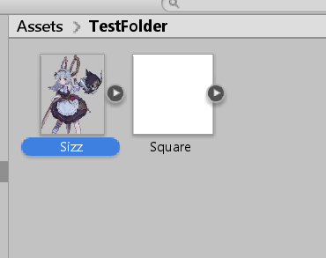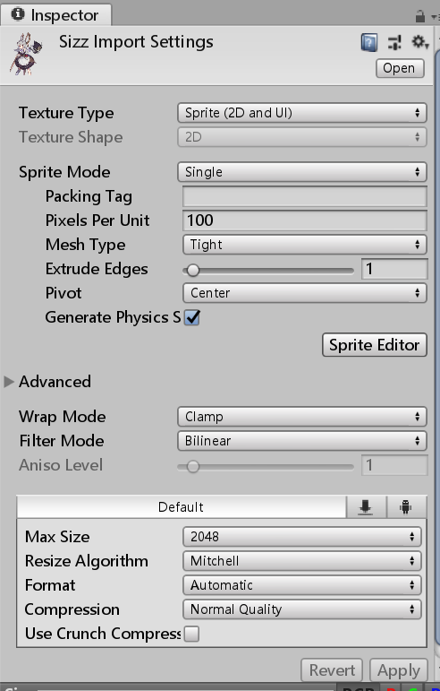

1. In Inspector -> SpriteEditor, hover at the face of the character, and record the “pivot” value. Be aware don’t save the file at this step.

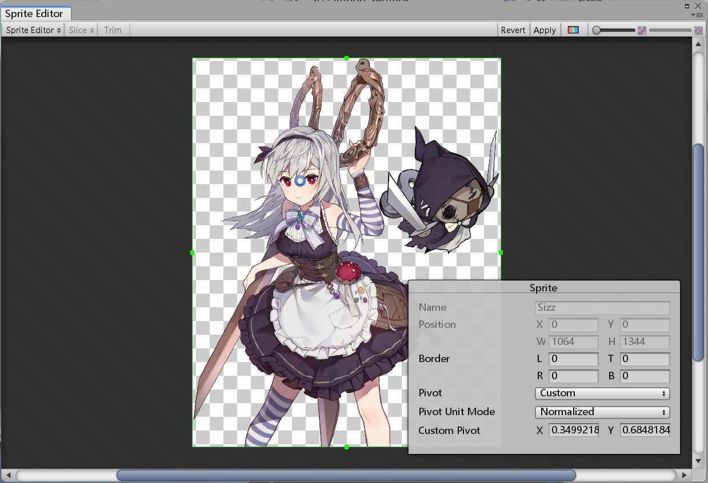

1. In Hierarchy create a UI/Image. If you don’t need additional settings for “No place for nerds” mode or passive description video, you can input the same GameObject under “FaceOriginChar” and “BattleChar” keys of the character gdata.

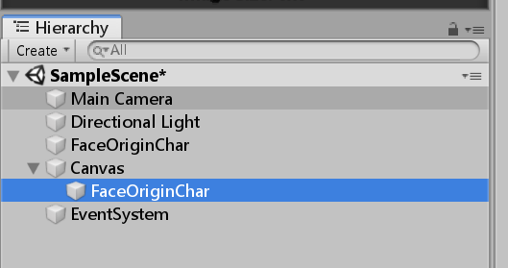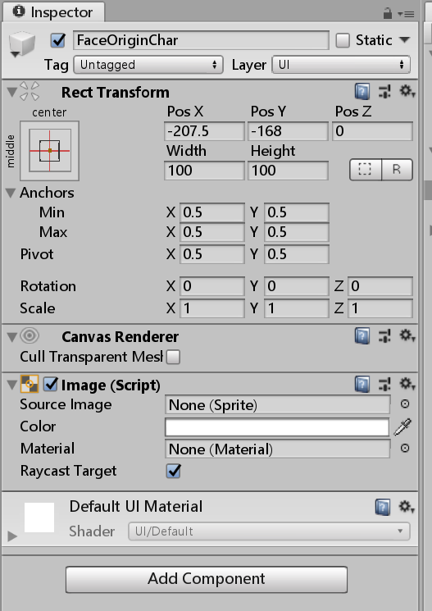

1. Replace “SourceImage” of the Image as your portrait sprite
2. Click SetNativeSize
3. Change pivot value to what you have recorded before
4. Set PosX and PosY to 0

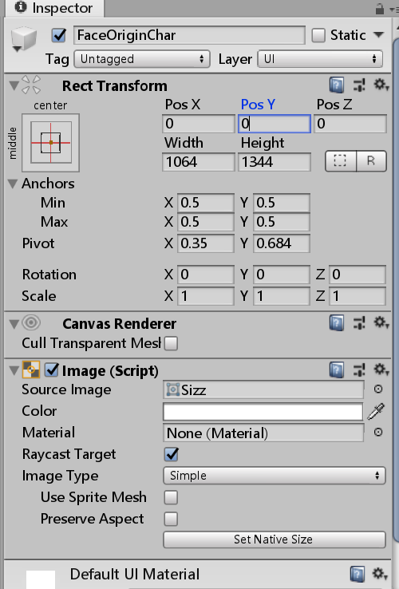

1. Drag the GameObject to the folder to be packaged, now it’s ready to create the AssetBundle